 CFG Gestion – DRT Toolkit
DRT Toolkit
User Guide
The purpose of this document is to describe the procedure to set up the DRT Toolkit. This document contains only specifications of the DRT Toolkit. For further information about the DRT and QuoteSource configuration, please consult the Sophis documentation.
November 2010
Date | Version | Author | Comment
08/11/2010 | 1.0 | Silas Pereira (Sophis)
14/12/2010 | 1.1 | Christophe Royer (Sophis)
Table of Contents
Installation 3
Content of the Deployment package 3
Version 3
DLL Deployment and dictionary file 3
Server Configuration 4
QuoteSource Configuration 4
DRT Configuration 5
The Prefix and SourceID 5
Snap 6
SQL Script 7
Populating the Table CFG_Prices 8
The field ISIN 9

Installation

Content of the Deployment package
The deployment package of the DRT toolkit for CFG Gestion contains:
- This User guide document;
- 2 DLL files: CFGAdapter.dll, CFGAdapterConfiguration.dll;
- A dictionary file: CFGDictionary.xml;
- A script SQL with the script to create the table CFG_Prices: CFGAdapter.sql;
- A version file;

Version
This application will run in Sophis Value v.4.1.1, and DRT Server v.6.1.0.3

DLL Deployment and dictionary file
1 - Copy the 2 DLL files (‘CFGAdapter.dll’, ‘CFGAdapterConfiguration.dll’) that came into the deployment package to the QuoteSource bin directory under the Sophis servers’ installation: ‘…\sophis\DRT\QuoteSource_v6.1.0\bin’
2 - Copy the dictionary file ‘DictionaryCFG.xml’ that came into the deployment package to the QuoteSource config directory under the Sophis servers’ installation: ‘…\sophis\DRT\QuoteSource_v6.1.0\config’

Server Configuration

QuoteSource Configuration
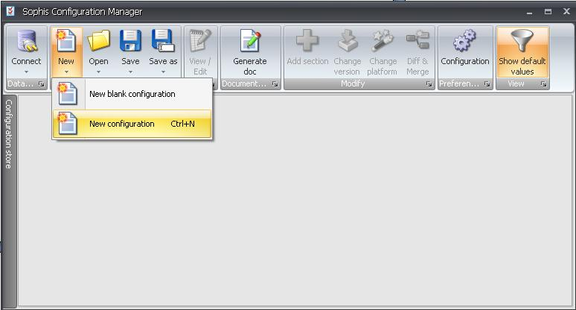
After copied the DLL files to the bin directory, open the Sophis Configuration Manager and then, create a new configuration file:

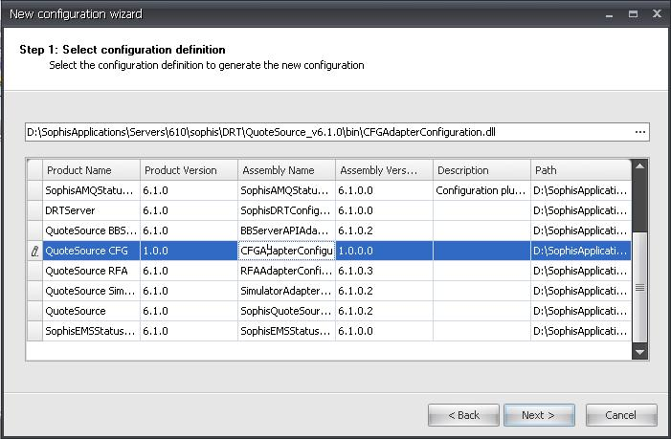
Click Next. In the list that appears, select the ‘QuoteSource CFG’ assembly:

Click Next and Finish. A new configuration window for the QuoteSource will open.
Under QuoteSource:Adapter:AdapterCommon set the StreamingDicionaryFile and the SnapshotDictionaryFile fields with the name and the relative path of the dictionary file:
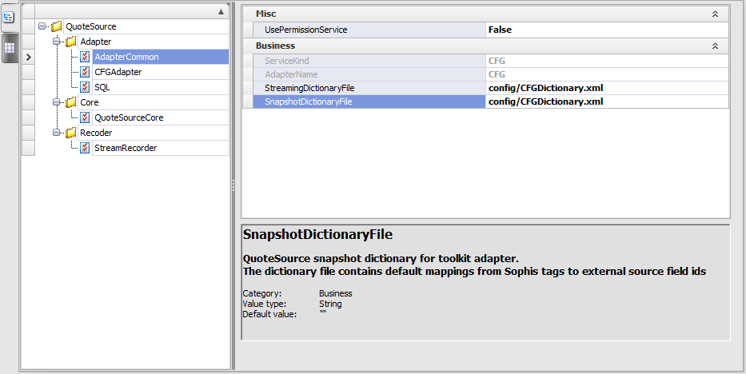
Under QuoteSource:Adapter:SQL set the DatabaseInstance, Username and Password fields.
Then, click in Save, then Save to File, and save it as ‘CFGadapter.config’ to the QuoteSource config directory under the Sophis servers installation: ‘…\sophis\DRT\QuoteSource_v6.1.0\config’

Quote Source Installation
In order to install the CFG Quote Source, right click on the ServerManager on in the Server Admin Console and select Add Server:
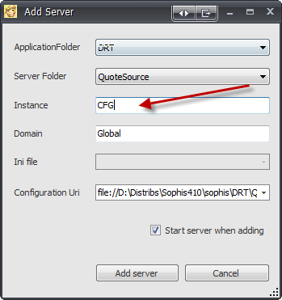
The name of the server must be ‘CFG’ (equals to the Source Id defined later).

DRT Configuration

The Prefix and SourceId
In order to set the DRT server to work with our QuoteAdapter, we need to set the correct prefix and SourceId that will be used to retrieve the topics.
To check how to set the other fields of the DRT configuration file such as DataConnection, please refer to the DRT Server User Guide provided with the installation of the server.
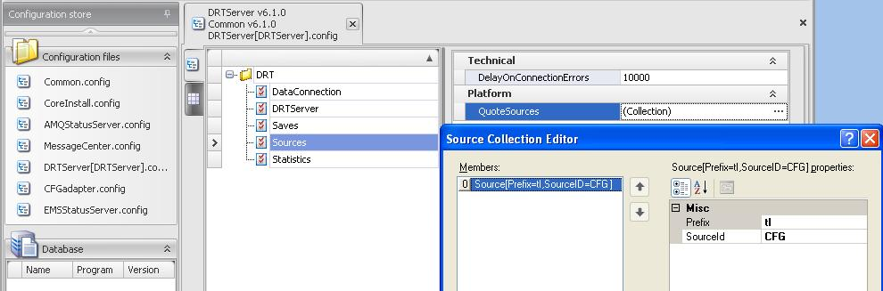
Open the DRT config file in the Configuration Manager. Under DRT:Sources:QuoteSources: click in the symbol ‘…’ in the end of the Collection field. A new window will be open:

In the prefix field set the value ‘tI’ (t for Triarch and I for IDNS), and in the SourceId field set the value ‘CFG’. This prefix corresponds to the ISIN field of the oracle database and it is explained in more details in the section ‘The field ISIN’ of this document.

Install Validation
If everything is correctly installed you should see the SourceId in the DRTService sources:
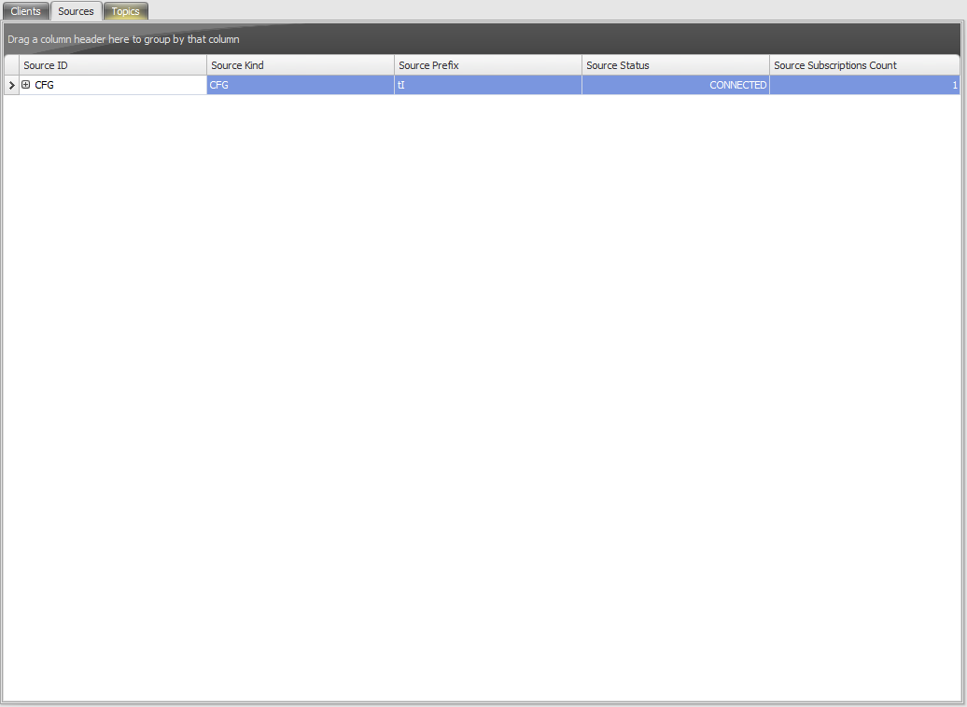

Snap
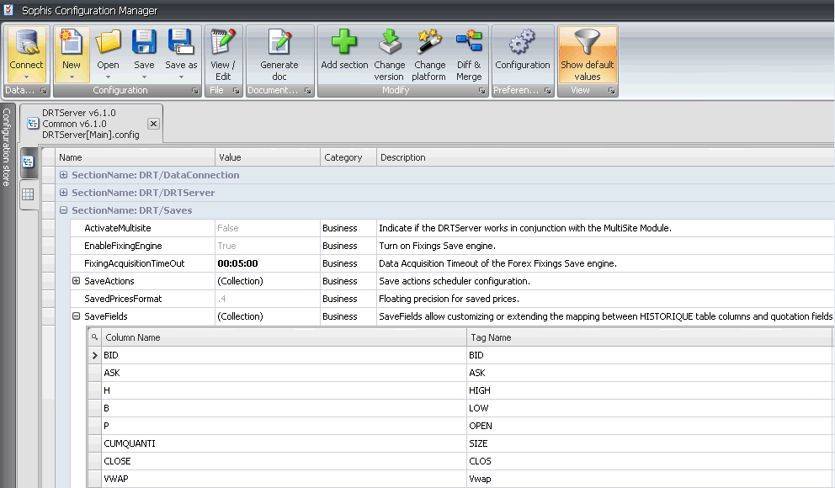
In order to save correctly the values in the custom columns of the table HISTORIQUE, we need to add them in the field SaveFields of the DRT configuration. For each custom column retrieved from the database, it must be created a different element in the SaveFields collection as shown in the following picture:

Save the config file under the DRT config folder.

SQL Script
We have to create the Oracle table ‘CFG_Prices’ to store the quotations that will be sent in real time to DRT. The script is provided in the delivery package in the file “CFGAdapter.sql”.
In order to upload new real time prices to the instruments in the Sophis database, this table must be filled with valid data.

Populating the Table CFG_Prices
The following script exemplifies a possible set of values in the table ‘CFG_Prices’:
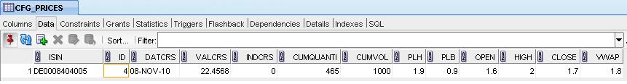
Insert into CFG_PRICES (ISIN,DATCRS,VALCRS,INDCRS,CUMQUANTI,CUMVOL,PLH,PLB,OPEN,HIGH,CLOSE,VWAP) values ('DE0008404005',sysdate,22.4568,0,465,1000,1.9,0.9,1.6,2,1.7,1.8);

The field ISIN

FID
In order to define which price should be sent in real time the FID must be populated in the DB with the following script (also available in ‘CFGAdapter.sql’).
INSERT INTO FIDLIST(ITEM, NAME, SPOT_RT, SPOT_SAVE) VALUES (1, 'LAST', 'LAST', 'LAST');
INSERT INTO FIDLIST(ITEM, NAME, SPOT_RT, SPOT_SAVE) VALUES (2, 'PLH', 'PLH ', 'PLH ');
INSERT INTO FIDLIST(ITEM, NAME, SPOT_RT, SPOT_SAVE) VALUES (3, 'PLB', 'LOW ', 'LOW ');

ISIN
The field ISIN corresponds to the reference of the instrument in the RIC window (CTRL+J). Which reference will be used depends of the prefix that will be set in the DRT Configuration. By default, the prefix will be set as ‘tI’ which means that the reference field to be filled is ‘Reuter‘. At the same time, the Global Prefix must be unchecked, and the fields Integrator and Source must be set as ‘Triarch’ and ‘IDNS’ respectively. The following picture illustrates this configuration:

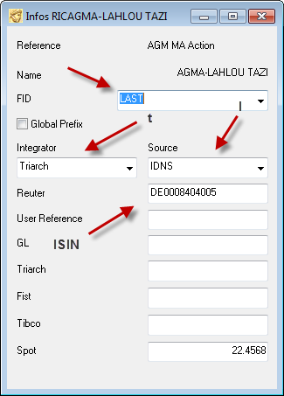

If a different prefix is set in the DRT configuration, certainly other field than ‘Reuter’
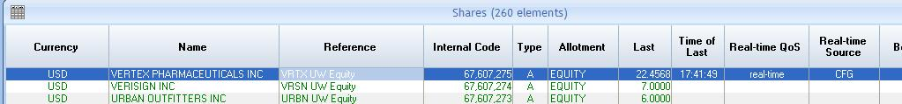
Once the row we have in the table ‘CFG_Prices’ contains the field ISIN with the value 'DE0008404005', which is the same value that the Share above contains in the ‘Reuter’ reference, this instrument will be updated by the QuoteSource. After that, some of the columns of the instrument will show the new values updated in real time. In the following picture we can see the ‘Last’ and the ‘Time of Last’ columns with the new values, and also the ‘Real-time QoS’ and ‘Real-time Source’ indicating respectively their values:

Don’t forget to “Activate the Real-Time Link” in your Sophis Client from File menu.

